CMPG171 Website Information

MCH Hardwares | 2577 Harchard Street Golfview

Mangaliso clement hlatswayo

34590919

**2020**

Contents

MCH HARDWARES 2

Homepage 3

About Us 4

Products 5

Adding items to cart 6

Buying items now 7

Complete Payment 9

Website Error 10

References 11

# MCH HARDWARES

I created an online shopping website called MCH HARDWARES, it is shopping company which manly focusses on rebuilding old and used technological materials into new and re-usable materials at a fair and reasonable price.

My company mainly focusses on buying used technical materials from customers and manufacture them at our factory by re-creating them in order to yield a new resource which can be sold at a fair price.

# Homepage

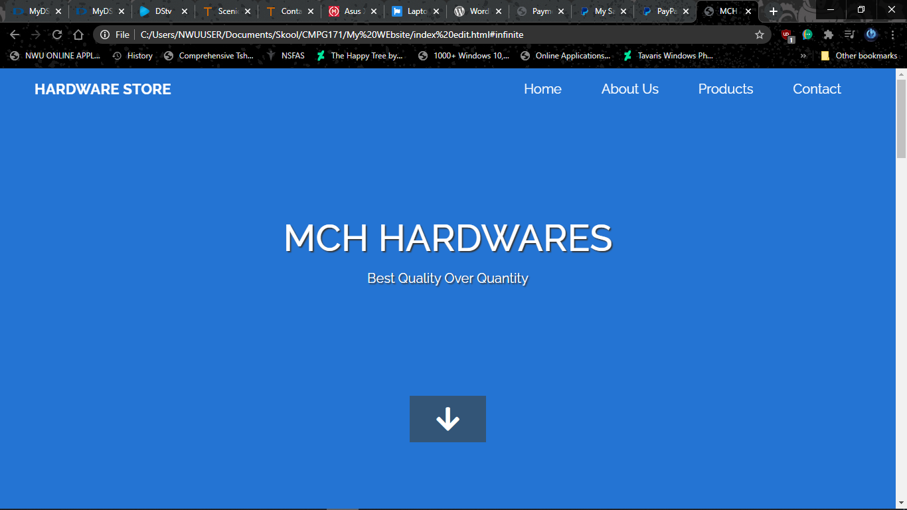

As you can see from the above screenshot is the homepage of my website containing the name of the company and as well as the slogan of the company. On the top right of the website are tabs of the pages that are in the website which contain all the information about the website and how it operates.

# About Us

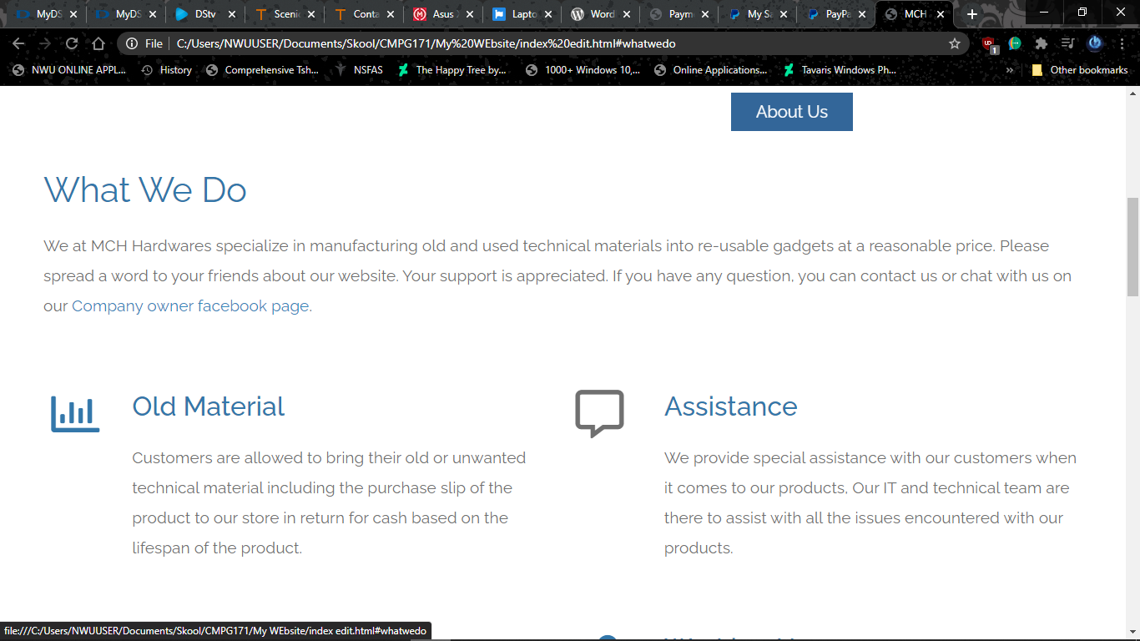

This screenshot shows the information about the website, what we do in my company, the material we use to re-new, the assistance provided to the customers, the way the company maintains it’s products that are being sold to the customers and as well the operating hours during the week.

# Products

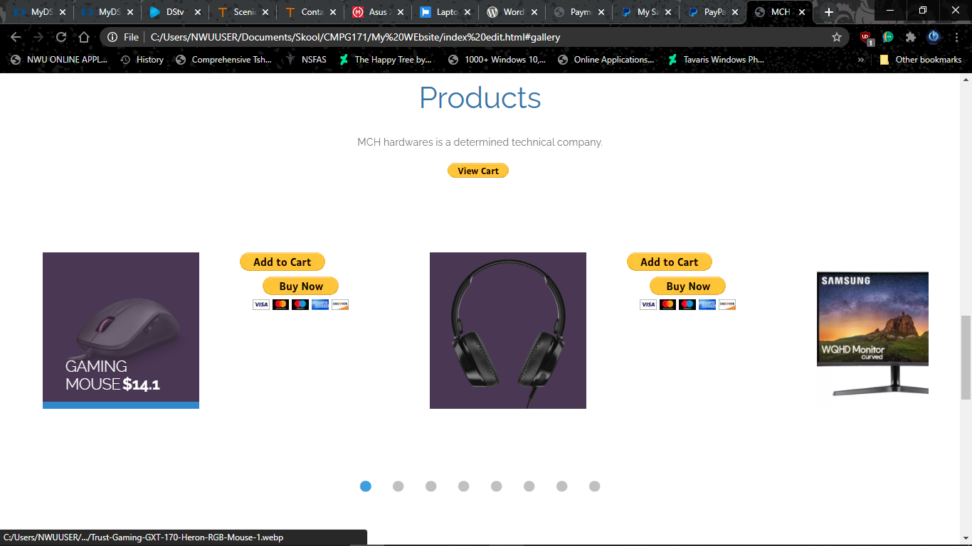

These are the review products which I used as an online platform for the kind of materials we have at our store. I used dollars for the products I sell in order to be able to use the “add to cart” and as well as “buy now” buttons. The form of purchase I used for my products is referred to as Payment Service Provider, in short PSP, is an online platform that one can use to create an account for free and use their resources in order to create a payment method like creating a “pay now “ button and use it in your own website in order to allows customers to purchase your products.

This PSP is created and sponsored by PayPal, a worldwide innovative company which helps people who want to start their businesses with investing and creating online platforms for their company websites.

**NB:** In order to see where your added items go to and the total of the added items, you have to have internet connection since the payment method is an online platform and cannot proceed to the secure checkout.

## Adding items to cart

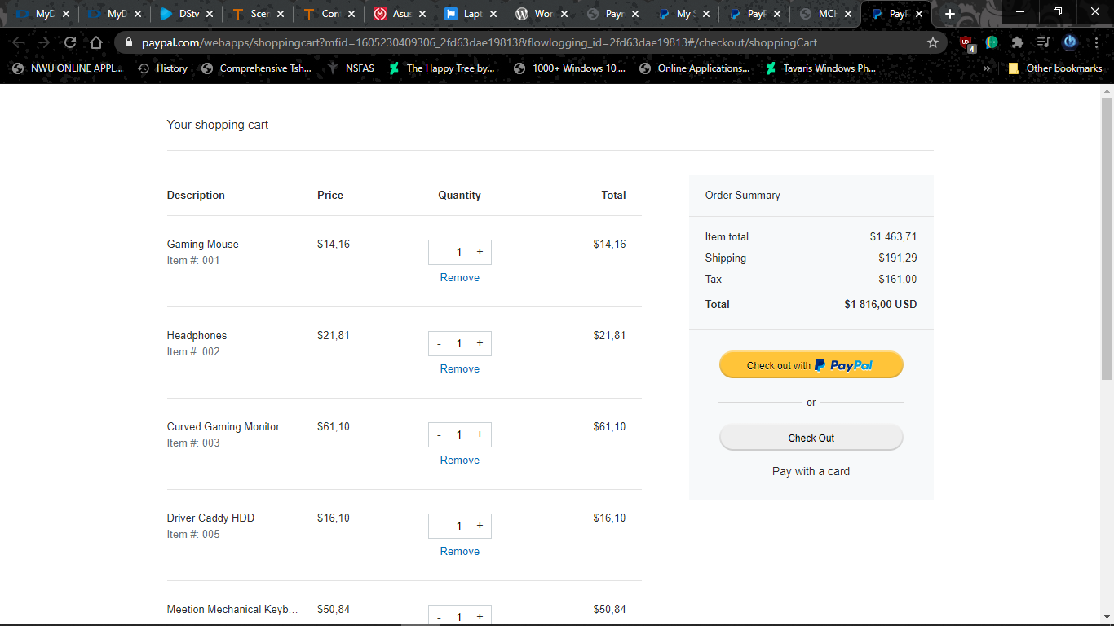

When you add items to a cart it will redirect you to this page which will show you all the items you have added to the cart and as well as the total of the items. Thereafter, you can see the two payment options you can use to pay your items, you can either use the PayPal checkout or normal checkout but note that if you use PayPal checkout you have to have a PayPal account which will then allow you to proceed to the next step of paying your items.

## Buying items now

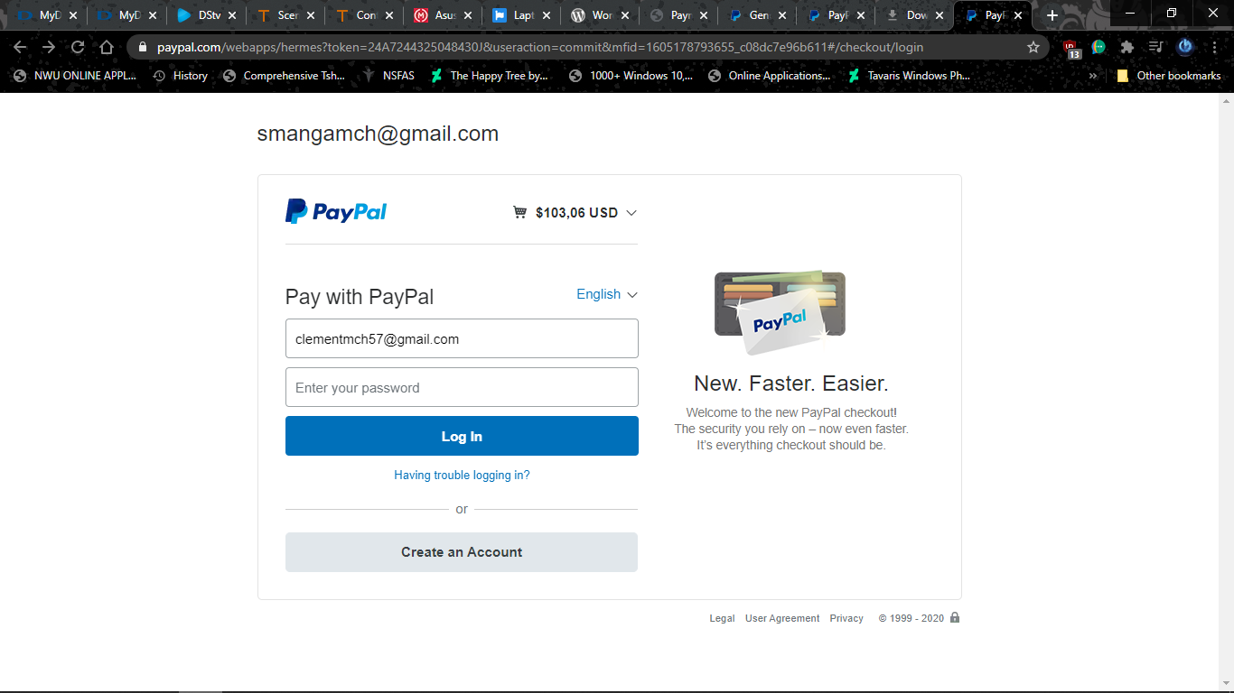

When you choose the “Buy Now” option, it will redirect you to this page but please note that I actually used my email above as a template to redirect the customers of my company to buy products but using the PayPal account.

I created two accounts in PayPal so that I can illustrate how the website works in terms of the payment processing cycle throughout the purchase. When you have logged in to your PayPal account, the following should occur in the page that you will be redirected to:

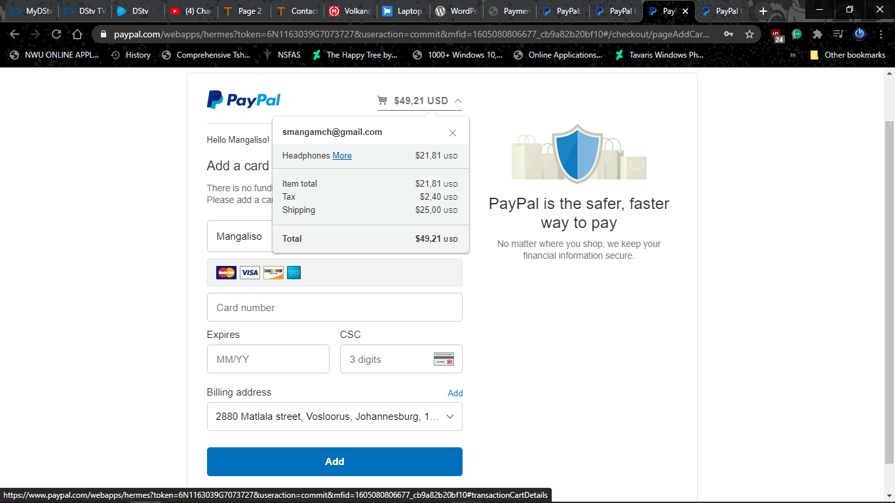

From this page you can see that it shows you what it is that you need to input in order to complete your purchase.

## Complete Payment

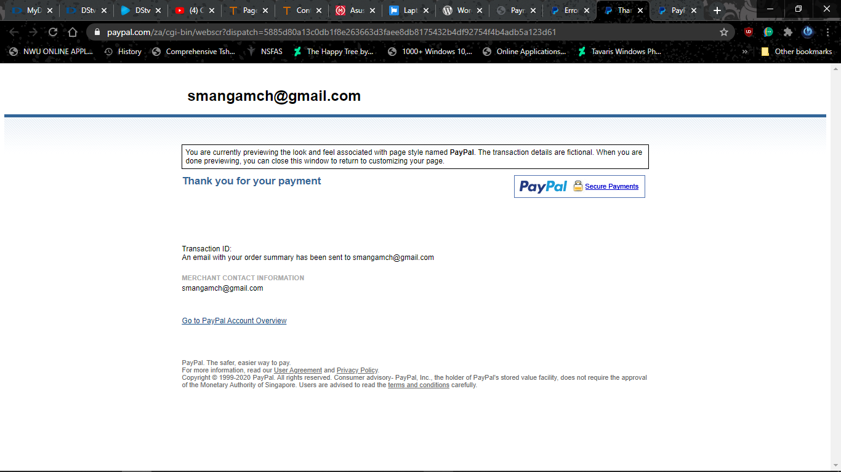

This is what you should expect after purchasing the website, I used my old banking details from NetBank in order to proceed to the final step but the was no any transaction since the business website I have created is not a legit website but for educational purposes. To review your statement of the purchase, there is a link below the page of the payment successful that is written Go to PayPal Account Overview or go to your emails to check for your order summary.

# Website Error

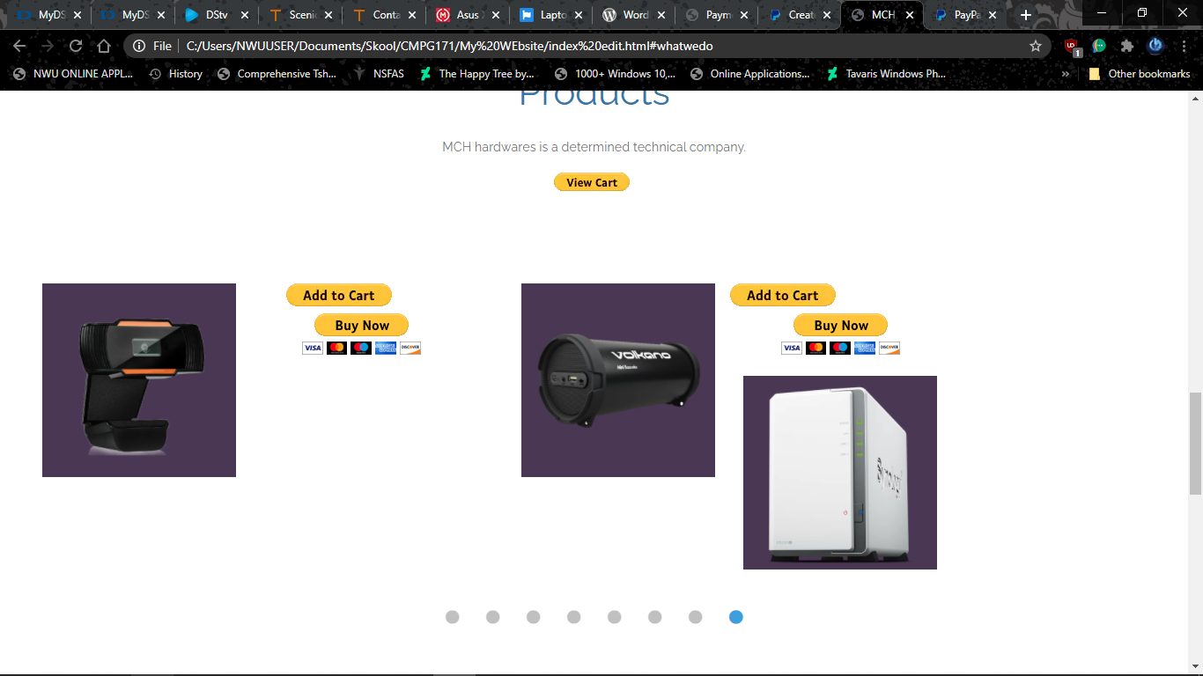

An unfortunate coding error occurred as I was to finish with the preview products of my company, there was a mix up of products when I tried to align them in order and unfortunately it was difficult for me to find the problem behind the coding since it seemed fine to me in terms of coding the alignment of the products and as well as their prices.

# References

Matrix Warehouse, 2020. *Matrix Warehouse.* [Online]   
Available at: https://matrixwarehouse.co.za/  
[Accessed 01 November 2020].

PayPal, 1999. *PayPal.* [Online]   
Available at: https://www.paypal.com/myaccount/settings/  
[Accessed 05 November 2020].

tooplate, 2020. *tooplate.* [Online]   
Available at: https://www.tooplate.com/view/2117-infinite-loop  
[Accessed 02 November 2020].